OOD2 “Digital Circuit” Project
Design Process
Jiaqi Ni, Kalina Petrova, Lumin Fan, Ishant Upadhyay
2014/12/17
Table of Contents
- Index and content………..……………………………….….....1
- Class Diagram……..………..……………………………….….1
- Class Explanation…..……..……………………………….….1-3
- Sequence Diagram ……….....………………………………….3
- Appendix………………………………………………………….4
- Appendix……………………………………………………….5-7

Class Diagram: See the appendix A.
Class/methods Explanation:
- Digital circuit Form: the main form for users to operate the application.
Functions: as described before, it will allow you to draw a digital circuit. So it is possible to add/delete/edit gates and add/delete connections.

- Connections Editor Form: a supported form which will allow users to edit the connections.

- Manipulator: This is the class which will contain the list of the gates and the list of the connections, so this can be the bridge of the form and the gate/connection class, users do the operations on the form, and this class processes the procedures.

Methods:
+Manipulator():
Constructor.
+Add1Connection(Connections c):
Add 1 connection between to the connection list.
+Add1Gate(Gate g):
Add 1 gate to the gate list.
+CalculateValue():
Calculate all gates’ value by calling the method in the gate class.
+Remove1Connection(Connections c):
Remove 1 connection from the connection list.
+Remove1Gate(Gate g):
Remove 1 gate from the gate list.
+ConnectionExsit(Gate l,Gate r):Bool:
Check whether the connection the user wants to add already exists.
+GetGateByLocation(Point p):Gate:
Get the gate by the mouse click position, if there is not such a gate, then return nll.
+SetAllGatesColor()
Set all gates’ color based on their out value.
+SetAllConnectionColor()
Set all connections’ color based on their left side gate’s out value.

- Connections: this is the class for the connection between 2 gates. So there will be 2 gates for one connection, the left one and the right one. Also there will be some property about the connection like its color and value.
Methods:
+Connections()
Constractor.
+SetLeft(Gate g)
Set the left gate for this connection.
+SetRight(Gate g)
Set the right gate for this connection.
+ConnectionValid(Connectioons c):Bool: check whether the connection is valid or not.
Example: Maybe some user is trying to make a connection from sink to source which is not allowed.

- Gate: this is the class for the gate, for every gate, they will have a unique ID, and some other properties like its background color, its incoming values and outcome value and location radius stuff.
Methods:
+Gate(Int ID,Type t)
Constractor.
+Allow1MoreAround():Bool
This method is used to check, when a user is trying to add 1 more gate, if it is allowed to put it around this gate (avoiding overlapping).
+InGate():Bool
If the user want to select a gate, then we need to get that gate according to user’s mouse click position, so we check if the potion is inside the gate, if it is, then return this gate.(no gate overlap, so if there is, it is a unique one.)
+InGateR():Bool
Same sa the ingate(), but we will have 2 shapes for the gates, so 2 methods.
+SetBG2Green()
Change the out value of this gate to 1;
+SetBG2Red()
Change the our value of this gate to 0.
+CalculateValues()
Calculate this gate’s out value based on the incoming values.

- File Helper: this is the class used for saving and loading files.
Methods:
+FileHelper()
Constructor.
+GettingManual()
This method will load the manual for the user. (since the manual is an optional task so this one is also optional.)
+LoadFromFile()
This method will let you be able to load the projects from the disk.
+SaveToFile()
This method will let you be able to save the projects to the disk.

- AND, SOURCE, NOT, OR, SINK
These five classes are the subclasses of the class gate; they all will have the method calculate values (because different gate has different ways to calculate values.)
And for “AND” and “OR” they will have 2 incoming values and 1 out value.
For “NOT” only 1 incoming value and 1 out value.
For “SOURCE” only out values and for “SINK” only 1 incoming value.

Sequence Diagrams: See the appendix B.

Appendix A:
Class Diagram:
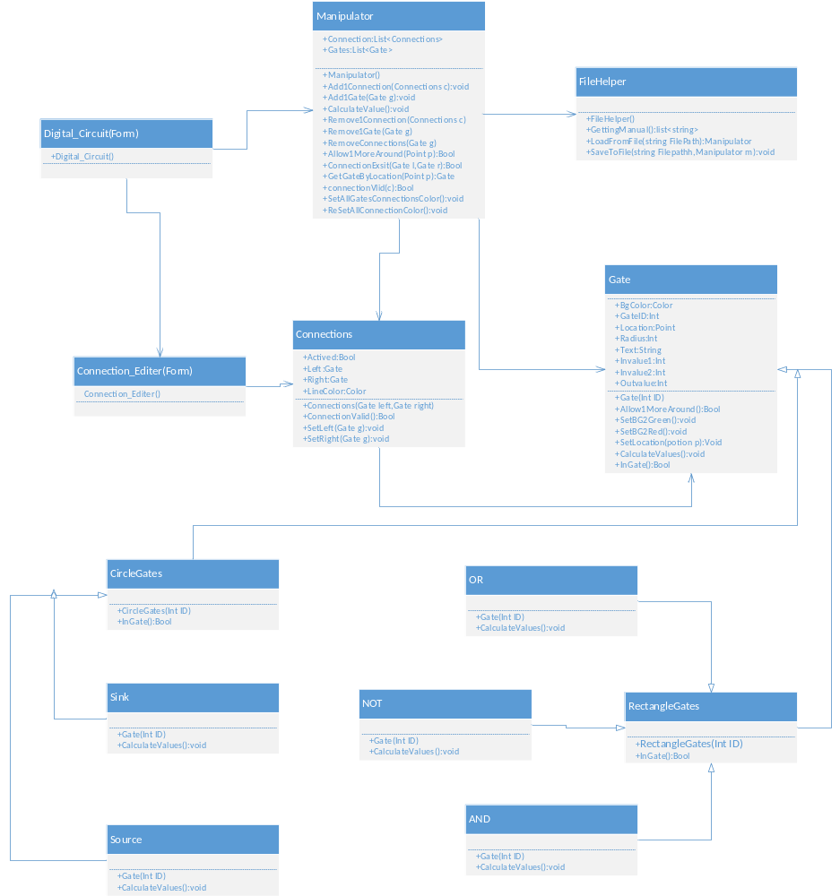

Appendix B:
Sequence Diagrams:
Calculate values for gates after successfully adding a connection:
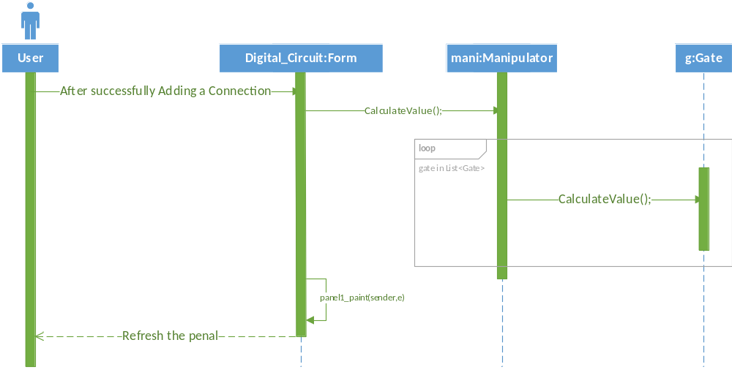
Delete gates 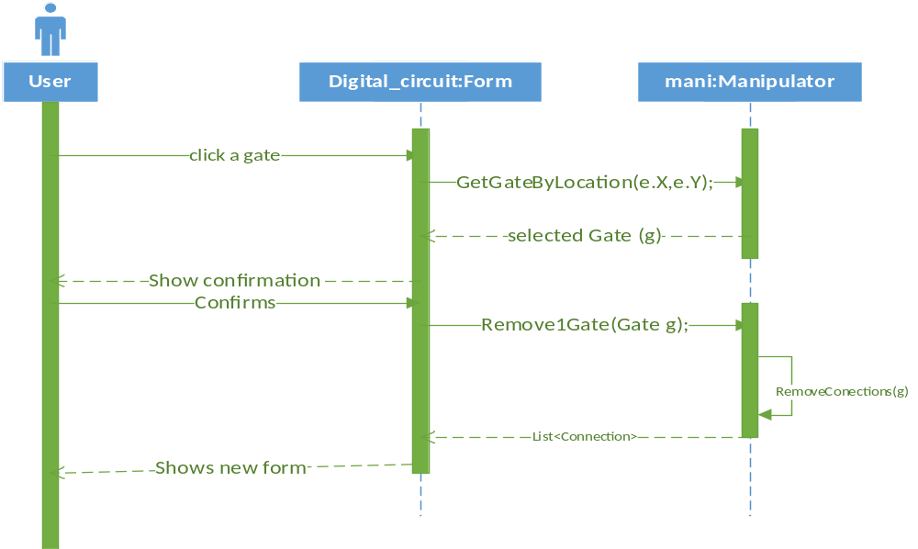
Delete connection
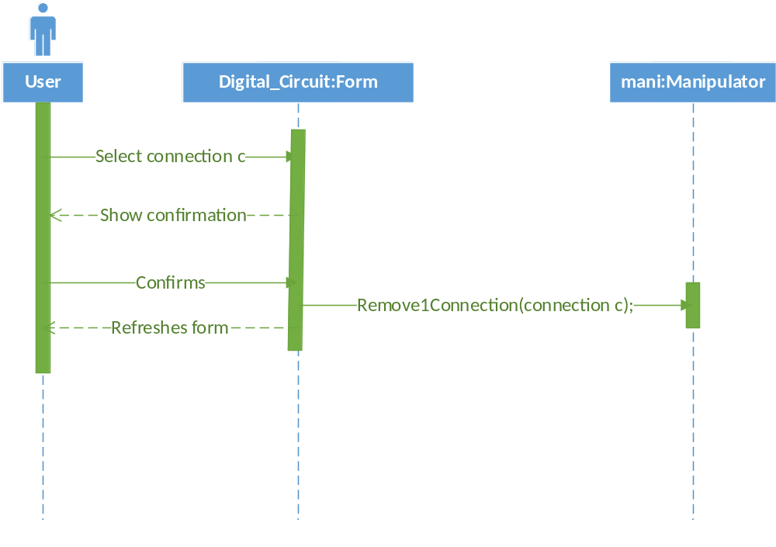
Add connection
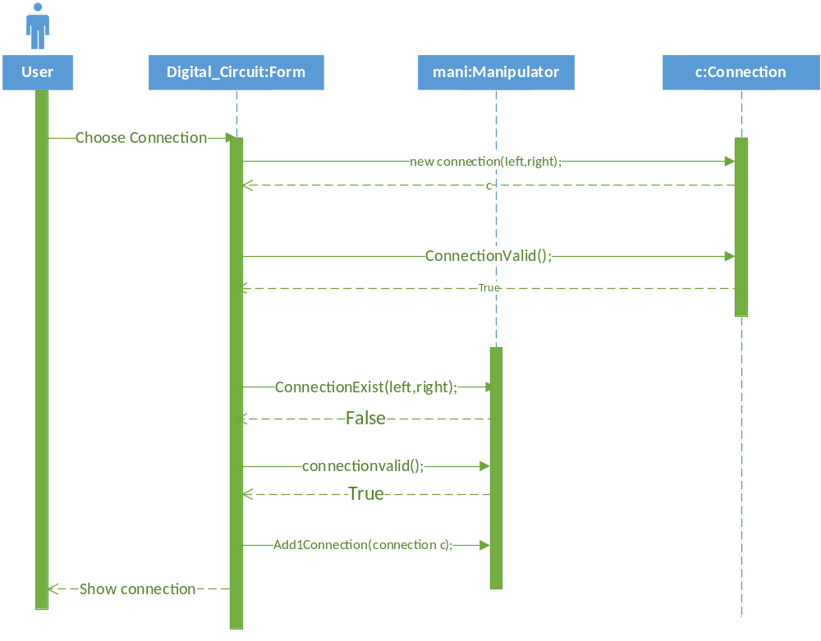
Add Gates 